**Hotfix & Repackage Process**

**Versions:**

* 2020R2-1.78
* 2022-1.68

**Projects:**

* PhoenixBaseTest
* PhoenixPoliceTest
* PhoenixFireTest
* PhoenixIATest

**Before Hotfix configuration**

We have to mention the path of configProperties in PropertiesFile

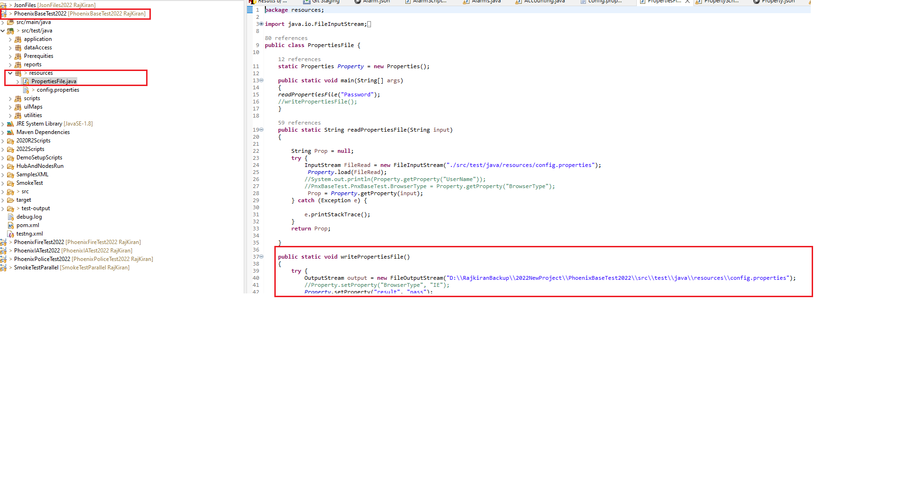

**Config File Configurations:**

* After receiving the request to run hotfix for certain version,
* we must change the version in config file .
* Need to change the Hotfix version of URL.
* Check the JSON Path is mapped correctly to the config file.

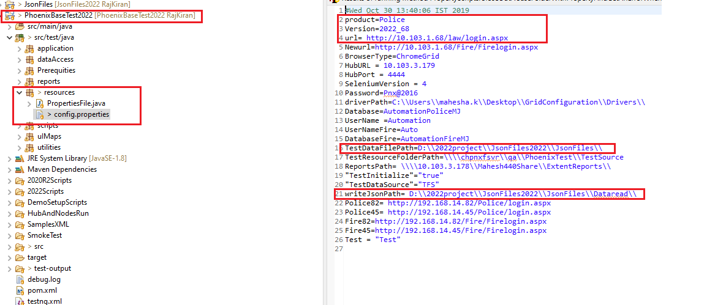

**Hotfix Process:**

**Scripts Details:**

* **Smoke scripts**
* **Entry smoke Scripts**
* **Functional Scripts**
* **Defect and RB scripts**

**Smoke Test Process:**

**Phoenix Base & Police Test Project:**

* After we receive Hotfix mail for certain product, initially we have to run the smoke Test for all product based on the version of product, In project smoke test xml separated by version in folder.
* After completion of Entry Smoke, we have to run the Functional scripts module wise
* Finally, we have to run the Defect Scripts Module wise.

**Phoenix Base Test Project: Phoenix Police Test Project:**

**Phoenix Fire Test Project:**

This project having same format as like as Base and Police Test project having separate folder smoke test by version.

**Phoenix IA Test:**

For IA product we having the smoke scripts in IA Project it also separated by versions in folder.

**Entry Smoke Test:**

**Phoenix Base & Police Test**:

After Ran and completion of Smoke Test, we must run the Entry smoke Scripts for all product and module. We have entry smoke scripts for some modules in base project and remaining in police project because we divided the modules by project.

**Phoenix Base Test Project: Phoenix Police Test Project**:

**Phoenix Fire Test Project:**

In Fire Project We have to run the smoke entry scripts for all modules and xml is created for each Modules.

**Phoenix IA Test Project:**

In IA Project we created the smoke entry Xml as base related modules and IA Related Modules .IA Related Modules is define the modules which having in IA Product , Base Related Modules are defining the Police Product Modules Or Global Modules

**Functional Scripts:**

Once after completion of both Smoke scripts and Entry Smoke Scripts, we have to run the functional scripts in the order of priority initially we have to run functional for the important modules once after its done we have to run the other modules

For functional scripts, we separated the scripts by version in that folder, and its separated by **sequential and non-sequential scripts**

**Xml files for Base Functional scripts: Xml File for police Functional Scripts**

**Defect Scripts:**

After completion of functional scripts we have to run the defect scripts and its having the separate folder under the respective version folders.

**Defect Xml for Base Project Defect Xml For Police Project:**

**Enhancement Scripts:**

At the end of above process, we have to run the enhancement testcases based on the version we are having the respective folders

**Enhancement Xml suites for 2022Scripts:**

**Repackage process**

**Smoke Test Process:**

**Note:** **No need to run the defect & release Broken scripts in Repackage**

After we are receiving the repackage mail for the certain version of product we have to run the Smoke scripts for all product, for repackage we have to run only smoke scripts, entry smoke and Functional.

**Phoenix Base & Police Test:**

**Phoenix Fire Test Project:**

This project having same format as like as Base And Police Test project having separate folder smoke test by version;

**Phoenix IA Test Project:**

For IA product we having the smoke scripts in IA Project it also separated by versions in folder.

**Entry Smoke Test:**

**Phoenix Base &Police Test Project**:

After Ran and completion of Smoke Test, we must run the Entry smoke Scripts for all product and module. We have entry smoke scripts for some modules in base project and remaining in police project because we divided the modules by project

**Phoenix Fire Test Project:**

In Fire Project We have to run the smoke entry for all modules and xml is created for each nodules.

**Phoenix IA Test Project:**

In IA Project we created the smoke entry Xml for base related modules and IA Related Modules.

**Functional Scripts:**

Once after completion of both Snoke scripts and Entry Smoke Scripts, we have to run the functional scripts in the order of priority initially we have to run functional for the important modules once after it’s done we have to run the other modules

For functional scripts, we separated the scripts by version in that folder, and it’s separated by **sequential and non-sequential scripts**

**Xml files for Base Functional scripts: Xml File for police Functional Scripts**

